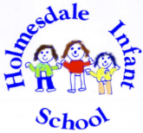
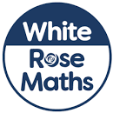
Year 2 Spring 1
Shape

Dear Parents/ Carers,
Year 2 children have just finished the unit ‘Shape’. Today we have sent home homework relating to their learning of shapes and pattern. At the end of term any child that has returned their completed homework will be entered into a draw to win a prize per Year group. Please return any homework to your class teacher by Wednesday 14th February 2024.
Please find attached the vocabulary cards relating to this unit-‘Shape’. The children are introduced to a vast range of mathematical vocabulary each term. Therefore, the partnership between home and school in helping them to retain, use and acquire a secure understanding of this vocabulary within their learning is paramount. Please keep sharing and using this vocabulary when learning about maths together at home.
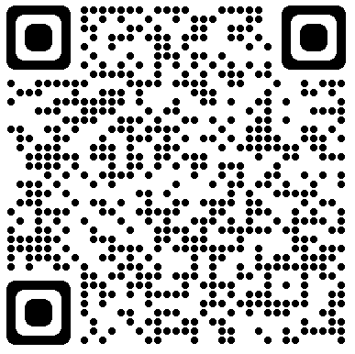
Attached is some guidance from White Rose (our predominant maths scheme used within school) on how best to support your child with learning about Shape at home. Please click on the QR code.

I have also attached below, a link to games that the children may be able to access at home to help them retain and secure this learning. As previously mentioned the app 1 minute maths by White Rose is free to download and also has a section on shape to support this.
https://www.topmarks.co.uk/maths-games/5-7-years/shapes
Thank you for your continued support with Maths at home.
Miss Farmer
Maths Co-ordinator

